# Write a Document Type Definition (DTD) to validate the XML file for book information and display the XML file as follows. Tree structure, Internal DTD and External DTD. The contents should be displayed in a table with five rows. The header of the table should be in Brown colour. And the Author names column should be displayed in dark blue colour and should be Capitalized and in bold. Use your own colours for remaining. Book information includes the following:

# 1. Book title

# 2. Author(s) Name

# 3. Genre

# 4. Copyright year

# 5. Book Edition

# 6. ISBN number

# 7. Publisher name

# 8. Book Price

# Source Code

1. Demonstrating DTD file

book.dtd

<!ELEMENT BOOKS (book)>

<!ELEMENT book (title,auther,ISBNnumber,publishername,editior,price)>

<!ELEMENT title (#PCDATA)>

<!ELEMENT auther (#PCDATA)>

<!ELEMENT ISBNnumber (#PCDATA)>

<!ELEMENT publishername (#PCDATA)>

<!ELEMENT editor (#PCDATA)>

<!ELEMENT price (#PCDATA)>

Books1.xml

<?xml version="1.0" ?>

<!DOCTYPE books SYSTEM "books.dtd">

<book>  
<book>

<title>java server page</title>

<author>hans bergsten</author>

<isbn>81-265</isbn>

<publisher>O'relilly</publisher>

<edition>second</edition>

<price>200</price>

</book>

<book>

<title>c</title>

<author>balaguruswamy</author>

<isbn>81-695</isbn>

<publisher>tata</publisher>

<edition>second</edition>

<price>400</price>

</book>

<book>

<title>web program</title>

<author>chirs bates</author>

<isbn>81-265</isbn>

<publisher>wiley</publisher>

<edition>second</edition>

<price>300</price>

</book>

</books>

1. Demonstrating XSD books.css

books

{

color:orange;

}

book

{

color:Red;

}

title

{

color:blue;

font-weight:bold; margin-left:10pt; display:block;

}

author

{

color:red;

font-weight:bold; margin-left:10pt;

}

isbn

{

color:green;

font-weight:bold; margin-left:10pt;

}

edition

{

color:red;

font-weight:bold; margin-left:10pt;

}

publisher

{

color:green;

font-weight:bold; margin-left:10pt;

}

Books.xsd

<?xml version="1.0" encoding="iso-8859-1" ?>

<xs:schema xmlns:x[s="http://www.w3.org/2001/XMLSchema](http://www.w3.org/2001/XMLSchema)">

<xs:element name="books">

<xs:complexType>

<xs:sequence>

<xs:element name="book" minOccurs="1" maxOccurs="unbounded"/>

</xs:sequence>

</xs:complexType>

</xs:element>

<xs:element name="book">

<xs:complexType>

<xs:sequence>

<xs:element ref="title" minOccurs="1" maxOccurs="1"/>

<xs:element ref="auther" minOccurs="1" maxOccurs="1"/>

<xs:element ref="isbn" minOccurs="1" maxOccurs="1"/>

<xs:element ref="publisher" minOccurs="1" maxOccurs="1"/>

<xs:element ref="edition" minOccurs="1" maxOccurs="1"/>

<xs:element ref="price" type="xs:string" minOccurs="1" maxOccurs="1"/>

</xs:sequence>

</xs:complexType>

</xs:element>

<xs:element name="title" type="xs.string"/>

<xs:element name="auther" type="xs.string"/>

<xs:element name="isbn" type="xs.string"/>

<xs:element name="publisher" type="xs.string"/>

<xs:element name="edition" type="xs.string"/>

<xs:element name="price" type="xs.string"/>

</xs:schema>

Books.xsl

<?xml version="1.0"?>

<?xml-stylesheet type="text/css" href="books.css"?>

<books xmlns:xsi="http:[www.w3.org/2001/xmlschema-instance](http://www.w3.org/2001/xmlschema-instance)" xsi:noNamespaceSchemaLocation="books.xsd">

<book>

<title>web program</title>

<author>chirs bates</author>

<isbn>81-265</isbn>

<publisher>wiley</publisher>

<edition>second</edition>

<price>300</price>

</book>

<book>

<title>java server page</title>

<author>hans bergsten</author>

<isbn>81-265</isbn>

<publisher>O'relilly</publisher>

<edition>second</edition>

<price>200</price>

</book>

<book>

<title>c</title>

<author>balaguruswamy</author>

<isbn>81-695</isbn>

<publisher>tata</publisher>

<edition>second</edition>

<price>400</price>

</book>

</books>

1. Demonstrating XSL books.xsl

<?xml version="1.0" encoding="iso-8859-1"?>

<xsl:stylesheet version="1.0" xmlns:xsl[="http://www.w3.org/1999/XSL/Transform](http://www.w3.org/1999/XSL/Transform)">

<xsl:template match="/">

<html>

<head>

<title> books</title></head>

<body>

<table border="1">

<tr><th>title</th>

<th> auther</th>

<th> isbn</th>

<th>publisher</th>

<th>edition</th>

<th>price</th>

</tr>

<xsl:for-each select="/books/book">

<tr>

<td bgcolor="green"><xsl:value-of select="title"/></td>

<td bgcolor="red"><xsl:value-of select="author"/></td>

<td bgcolor="cyan"><xsl:value-of select="isbn"/></td>

<td bgcolor="yellow"><xsl:value-of select="publisher" /></td>

<td bgcolor="silver"><xsl:value-of select="edition" /></td>

<td bgcolor="blue"><xsl:value-of select="price" /></td>

</tr>

</xsl:for-each>

</table>

</body>

</html>

</xsl:template>

</xsl:stylesheet>

Books3.xml

<?xml version="1.0"?>

<?xml-stylesheet type="text/xsl" href="books.xsl"?>

<books>

<book>

<title>java server page</title>

<author>hans bergsten</author>

<isbn>81-265</isbn>

<publisher>O'relilly</publisher>

<edition>second</edition>

<price>200</price>

</book>

<book>

<title>c</title>

<author>balaguruswamy</author>

<isbn>81-695</isbn>

<publisher>tata</publisher>

<edition>second</edition>

<price>400</price>

</book>

<book>

<title>web program</title>

<author>chirs bates</author>

<isbn>81-265</isbn>

<publisher>wiley</publisher>

<edition>second</edition>

<price>300</price>

</book>

</books>

# Execution Procedure

Step1: Type all html programs in notepad or any text editor and save the files. Step2: open appropriate xml files in web browser for getting output.

# Output

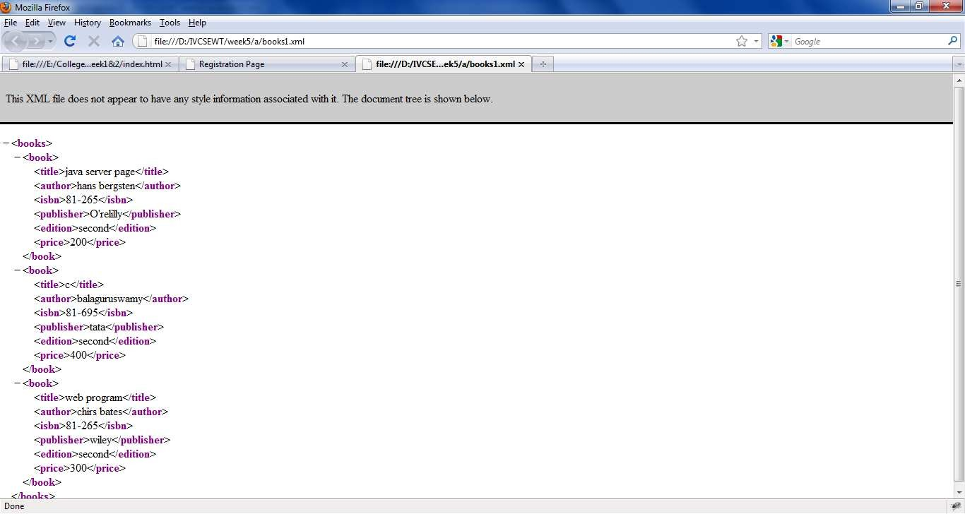

**Figure 1: Demonstrating DTD**

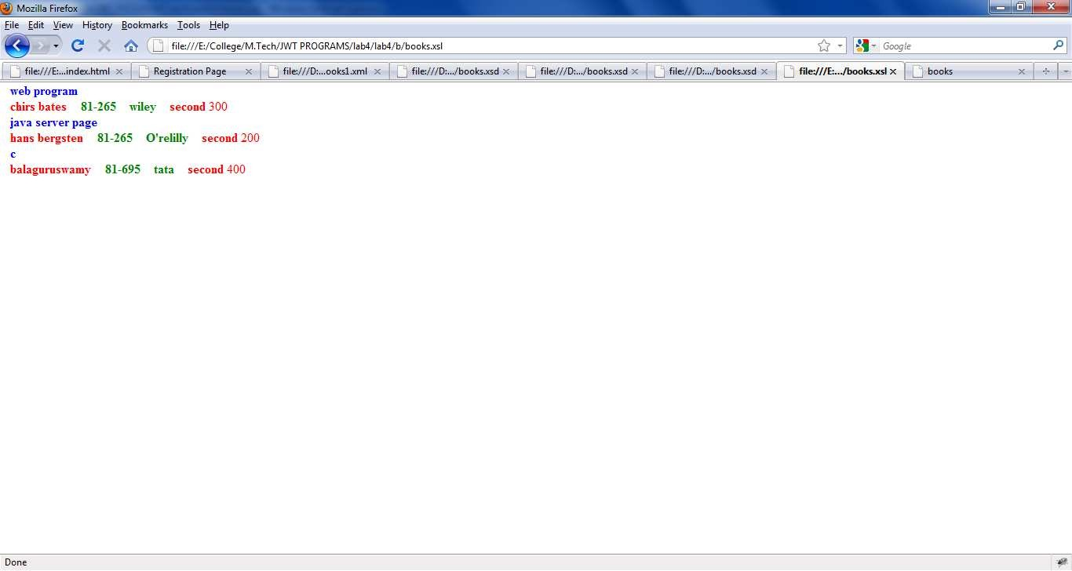

**Figure 2: Demonstrating XSD**

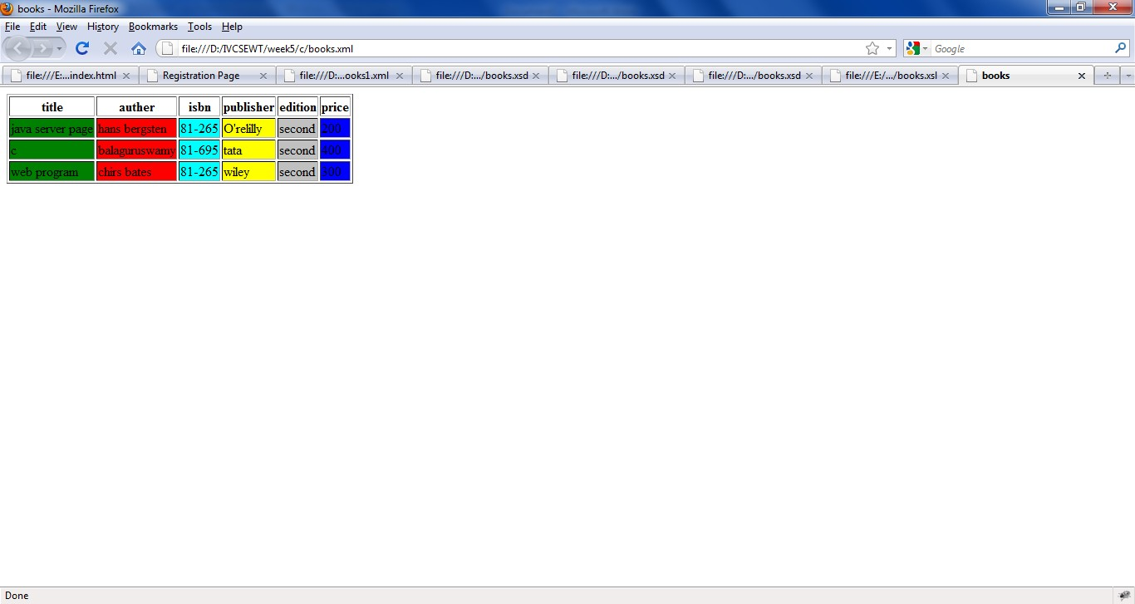

**Figure 3: Demonstrating XSL**